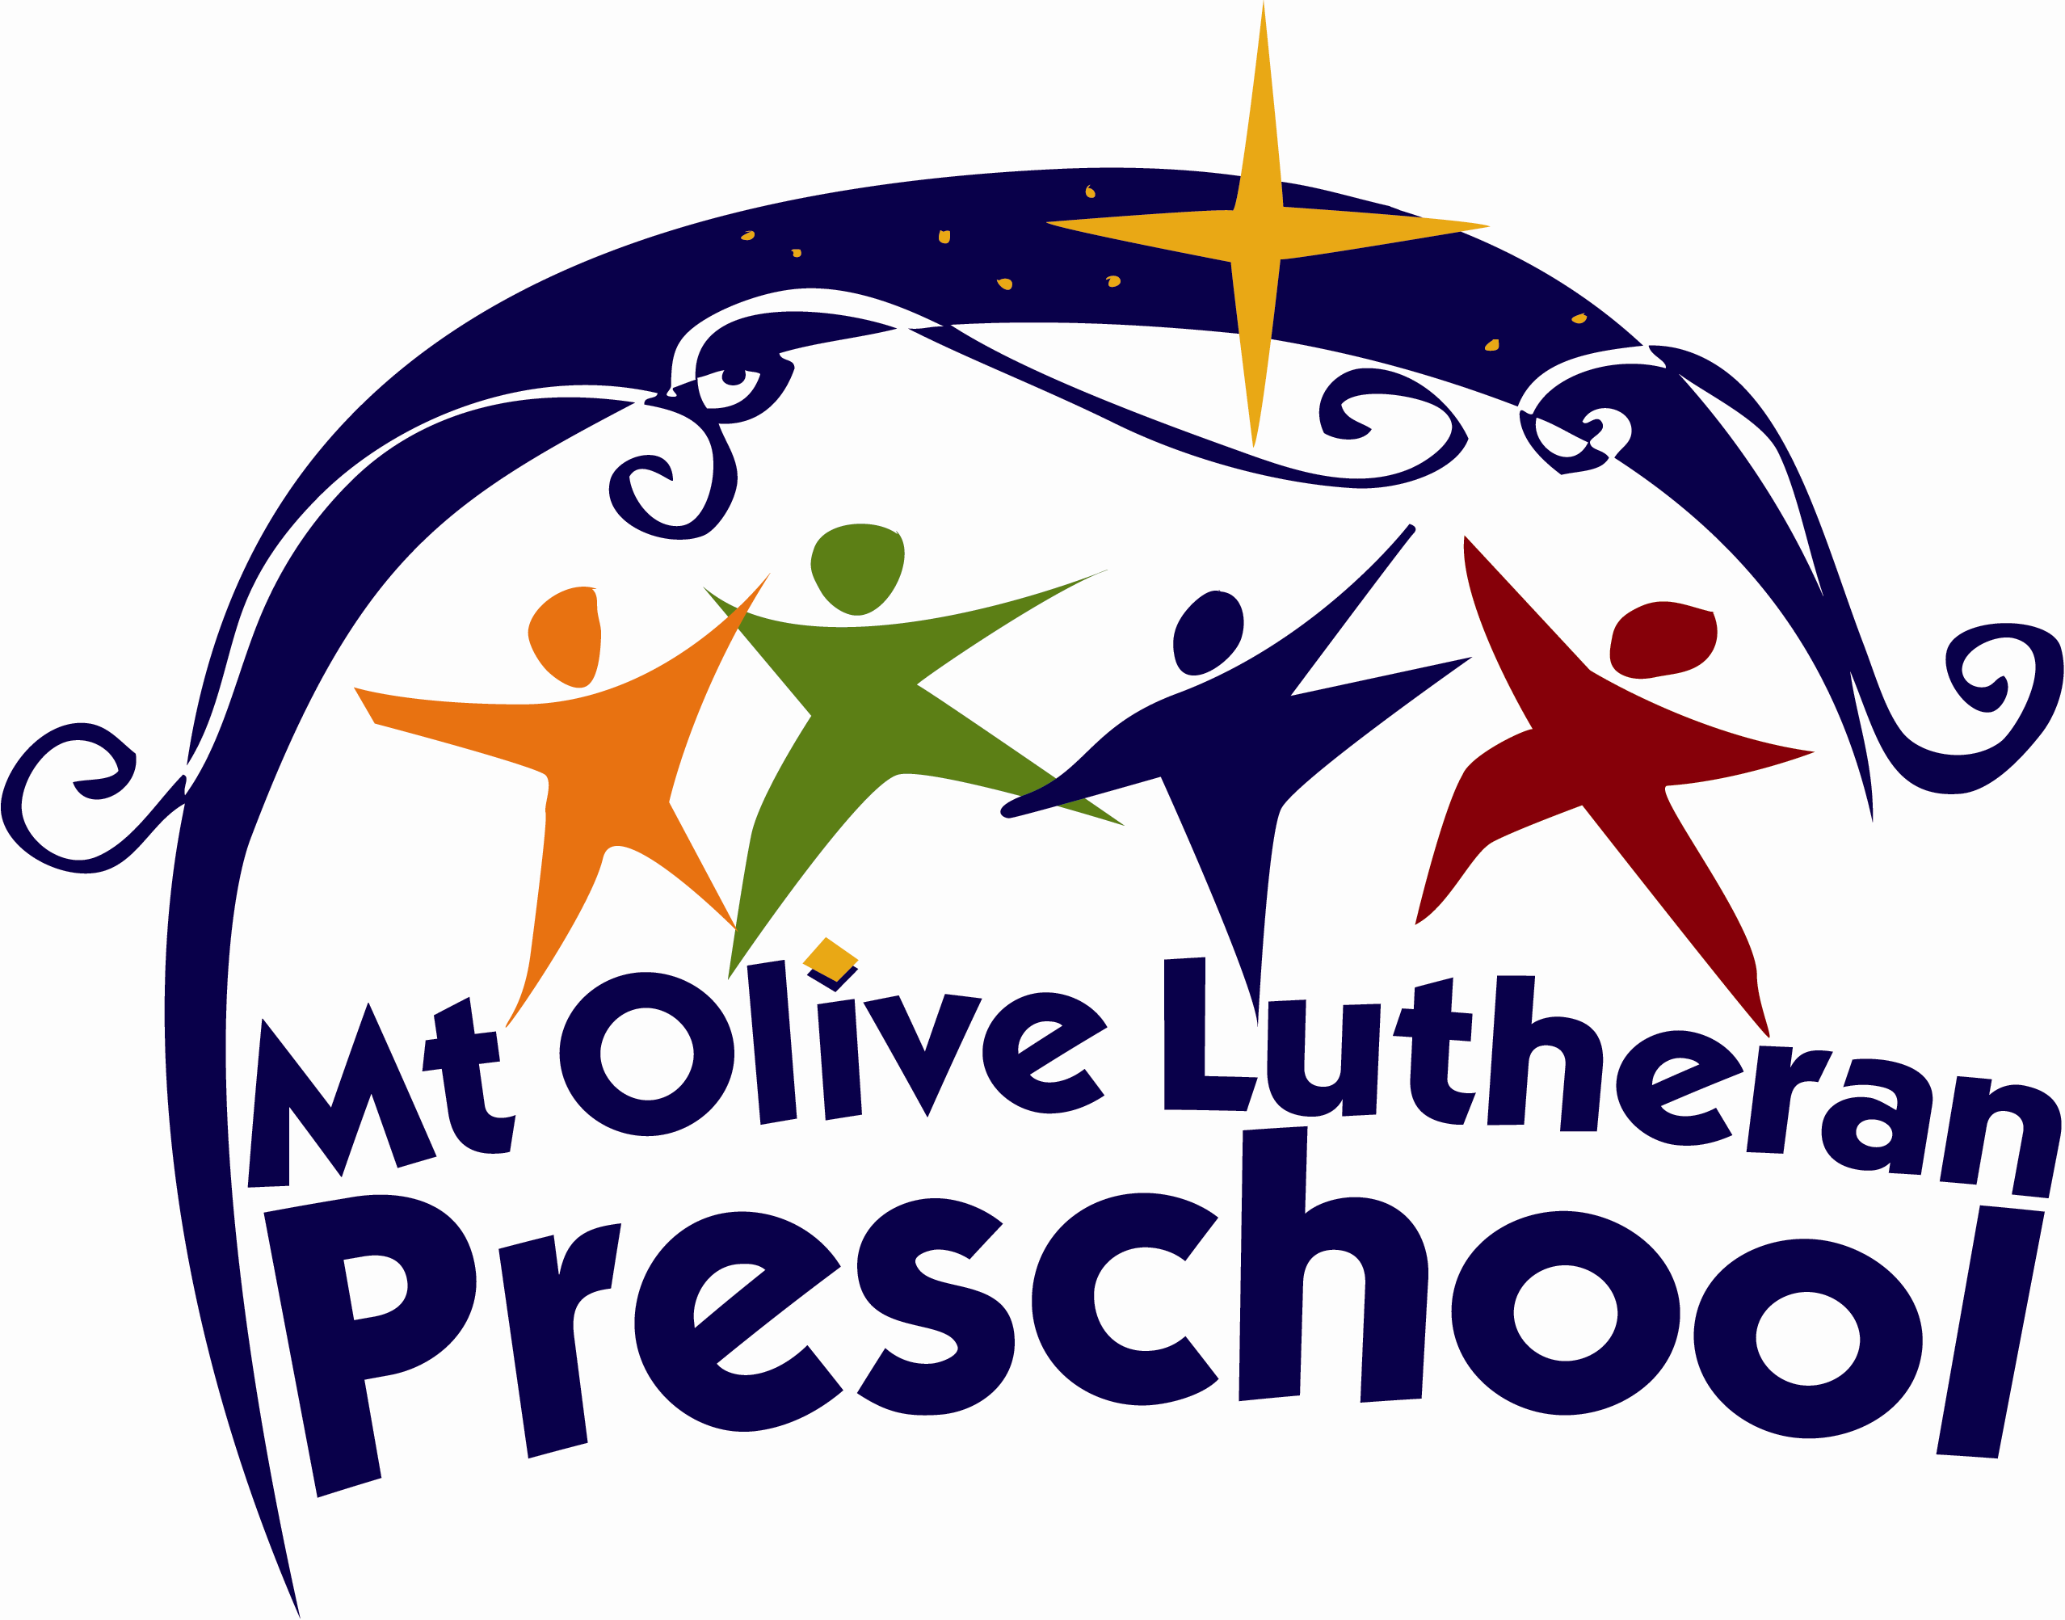

Preschool Information Packet
2026-2027

Thank you for your interest in our preschool. We look forward to offering outstanding and unique experiences for your child!

Mission Statement

Growing in faith and love by spreading the Word of our Lord and Savior Jesus Christ
by providing a Christ-centered experience for young children.

Philosophy

- Mt. Olive Lutheran Preschool is a joint ministry that involves the congregation,
community, staff, family and child(ren).
- Mt. Olive Lutheran Preschool provides a warm, loving Christ-centered environment where children can develop spiritually, socially, intellectually, emotionally, physically and creatively.
- We believe that each child is a unique and special child of God.
- We believe that learning is done best through developmentally appropriate activities and play.

School Curriculum

Our curriculum is continually and carefully planned to provide up-to-date, research-based learning opportunities for all children. Mt. Olive Lutheran Preschool students learn to achieve success and build a positive self-image and a life-long love for learning.
The curriculum includes:

  - Bible Stories and Faith Building Activities, including weekly chapel for
4-year-olds
  - Language Development (Visual, Auditory)
  - Reading and Mathematics Readiness
  - Science Exploration
  - Art Activities
  - Motor Coordination

(803) 781-7180
preschool@mtolivesc.org
1541 Lake Murray Blvd.
Columbia, SC 29212
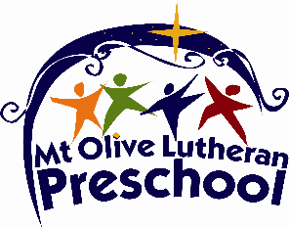

Classes Offered
2026-2027

Two-year-old Class
Mondays, Wednesdays and Fridays from 9:00 a.m. until noon

The two-year-old class focuses on learning how to sit through circle time (calendar, weather, etc.), how to function in a group and how to follow directions. Colors, shapes, counting and zoo-phonics are taught in this class. Learning songs and poems through repetition are integrated throughout the curriculum. The children also learn Bible Stories, centered around Creation, that teach them about God’s love for them. The class includes free-play, craft time, playground and big room time as well.

Three-year-old Class
Tuesdays, Wednesdays, and Thursdays from 9:00 a.m. until noon

The backbone of our curriculum is Zoo-Phonics into which we integrate math, science and social studies. This class has seasonal, monthly themes that are woven in throughout the year. Some of children’s beloved literature, along with many other favorite, well-known, books give us lots of inspiration for learning, plus the fun of crafts, games and songs. The children also learn Bible stories that teach them about God’s love for them. The class includes circle time, small group instruction, free-play, craft time, playground and big room time. You can see videos of zoo-phonics in action at www.zoo-phonics.com.

Four-year-old Class
Mondays-Thursdays from 9:00 a.m. until noon
Lunch/Enrichment on Tuesday until 1:00 p.m.

We offer a rigorous class for our four-year-olds designed to prepare them for kindergarten. We want our students entering kindergarten confident and capable. We achieve this through mornings full of learning that just happen to be fun! The backbone of our curriculum is Zoo-Phonics. We integrate excellent forms of children’s literature, as well as science, social studies and math. Learning is further extended with crafts, games and songs to bring learning to life. As part of the program, we teach proper letter formation for which kindergarten teachers are very grateful. We also offer many pre-reading opportunities such as learning book-handling and reading skills with paper copies of easy readers.

There is also plenty of time for the important work of childhood – play. Both unstructured (free play) and guided play time (small group activities and dramatic play centers) are offered each day. The children get daily playground time as well.

Throughout all of these activities, the children learn about God’s creation and His love for them. The children have a Bible memory verse, focus on a Fruit of the Spirit, and attend weekly chapel.

B.A.M! (Bible, Arts, Music)
Fridays from 9:00 a.m. until noon, Available only to 3- and 4-year-olds who are already enrolled

Separate from our regular age-level classes, B.A.M! (Bible, Arts and Music) is offered to our 3- and 4-year-olds as a once-a-week add-on option. It will include Bible stories, arts exploration, crafts, music and free-play. The goal of this time will be to reinforce child-appropriate skills learned in the classroom and provide a time of multi-age level play.

Registration Information
and Program Fees
2026-2027

Calendar and Classes:

- Mt. Olive Lutheran Preschool will follow Lexington/Richland School District #5 calendar for in-service days, holidays, winter and spring breaks.
- Student letters will be sent out the week of August 3rd to inform parents of child(ren)’s classroom teachers.
- On Tuesday evening, September 1st, parent orientation will be held.
- On Wednesday, September 2nd, we will have a meet the teacher drop-in for students.
- On Thursday, September 3rd, school will begin for the 3- and 4-year-old classes.
- On Friday, September 4th, school will begin for the 2-year-old class.

Forms Required for Enrollment:

- Each child must have the registration form completed and submitted along with the non-refundable registration fee to be enrolled.
- A S.C. Health/Immunization certificate must be on file by September 1, 2026.

Registration Fee (non-refundable)
$150/year ($75/siblings)
The registration fee is payable at the time of registration and is your financial commitment to hold your child’s place until school begins.

Supply Fees
Paid once yearly (due September) or split into two payments.
2-Year-Olds $130/year or $65 in Sept. and Jan.
3-Year-Olds $130/year or $65 in Sept. and Jan.
4-Year-Olds $160/year or $80 in Sept. and Jan.

Monthly Tuition
Tuition payments are due on the first of each month, made payable to: Mt. Olive Lutheran Preschool. A full month’s tuition is due regardless of the number of days attended, September through May.
 2-Year-Olds 3 days, M/W/F $220
3-Year-Olds 3 days, T/W/Th $220
4-Year-Olds 4 days, M-Th $235
B.A.M! F; open to 3’s/4’s only $50

Returned Check Fee/Late Fee $30
The tuition payment is considered late after the tenth of the month.

